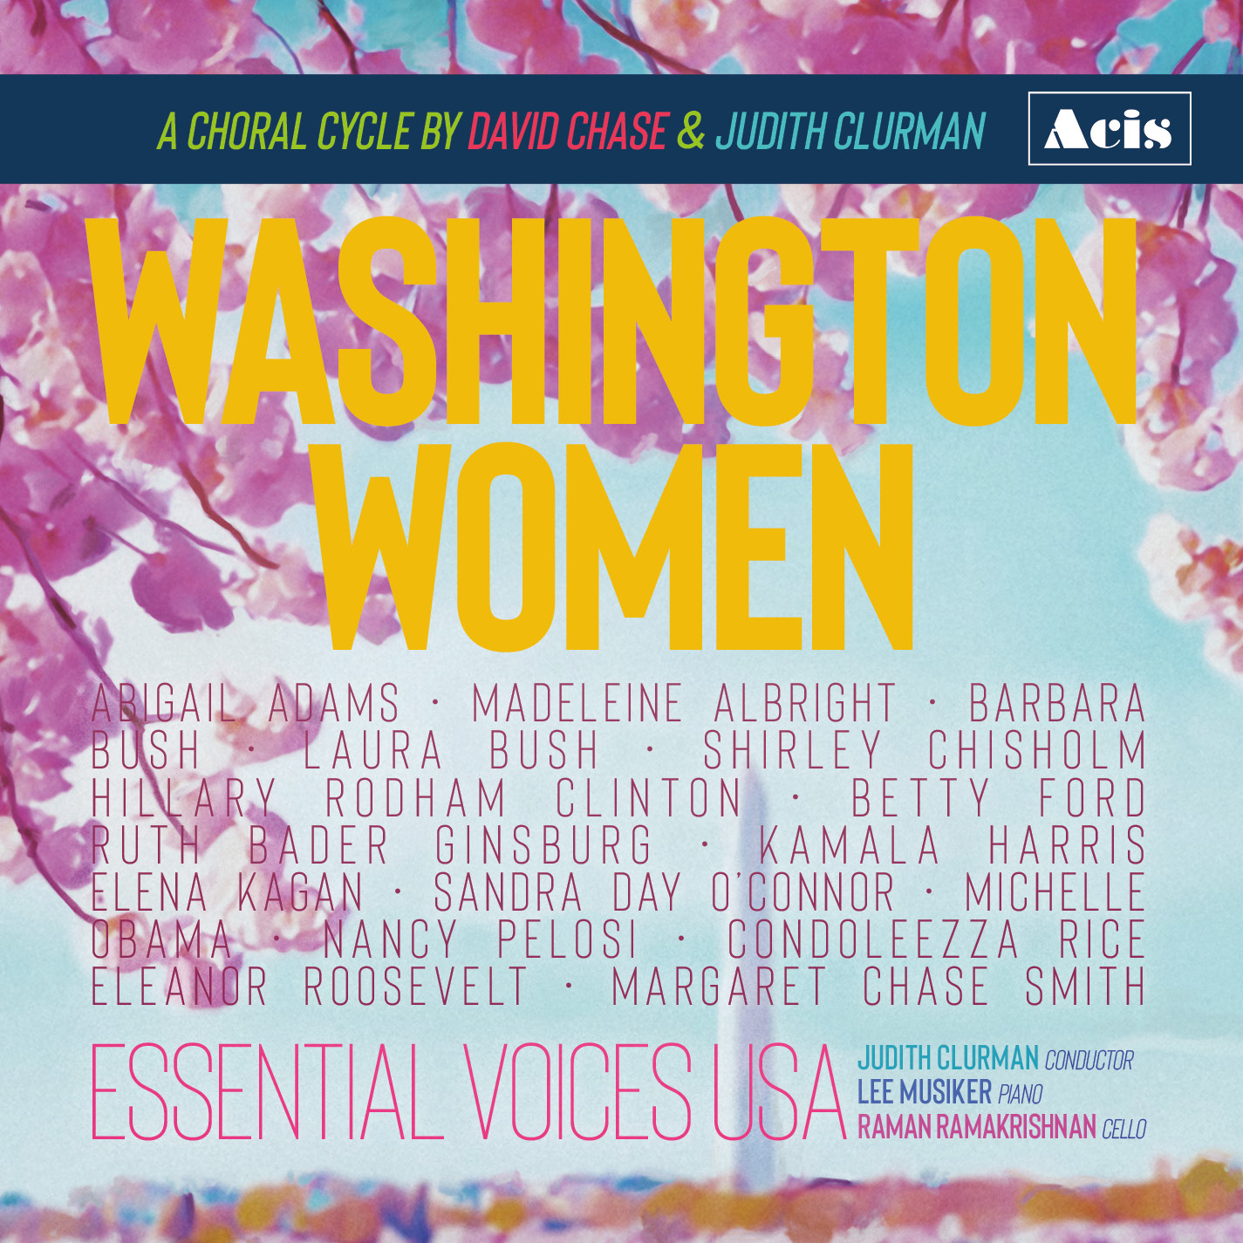

October 8, 2022

Essential Voices USA, Judith Clurman, Music Director and Conductor, announces the release of WASHINGTON WOMEN, a new collection of choral songs by David Chase and Judith Clurman. It is scored for mixed chorus, piano and cello. The texts are taken from speeches, opinions, and interviews of sixteen remarkable women from across the political spectrum, all of whom spent part of their lives associated with Washington DC - First Ladies, Senators, Congresswomen, Supreme Court Justices, Secretaries of State, Vice President, and Speaker of the House of Representatives: Abigail Adams, Madeleine Albright, Barbara Bush, Laura Bush, Shirley Chisholm, Hilary Rodham Clinton, Betty Ford, Ruth Bader Ginsburg, Kamala Harris, Elena Kagan, Michelle Obama, Sandra Day O’Connor, Nancy Pelosi, Condoleezza Rice, Eleanor Roosevelt, Margaret Chase Smith. The singers of Essential Voices USA are joined by pianist Lee Musiker and cellist Raman Ramakrishnan.

The recording, on Acis (APL27921), can be streamed on all platforms. The published score is available through Hal Leonard (HL00329483).

The World Premiere performance of WASHINGTON WOMEN took place on July 1, 2022, when six movement were performed on National Public Radio’s Tiny Desk Concerts (NPR video link).

Performances are planned during International Women’s Month, in March, 2023.

PROMO VIDEO:

https://vimeo.com/757025322/4b92d1c4b7

LINKS FOR LISTENING:

• Spotify:
https://open.spotify.com/album/4aY9ZgYJAWC1rL6VrerEue

• Apple Music:
https://music.apple.com/us/album/washington-women-a-choral-cycle-by-david-chase/1647536842

• Amazon Music:
https://amazon.com/music/player/albums/B0BGNDRD3F?marketplaceId=ATVPDKIKX0DER&musicTerritory=US&ref=dm_sh_NLKHHPVHP27BSvDB1eWE4ZfWg

